# IBM – Nalaiya Thiran Assignment 1 SMART HOME

**Submitted by**

**Jeba Mercy.R**

**960219104050**

**CIRCUIT DIAGRAM**

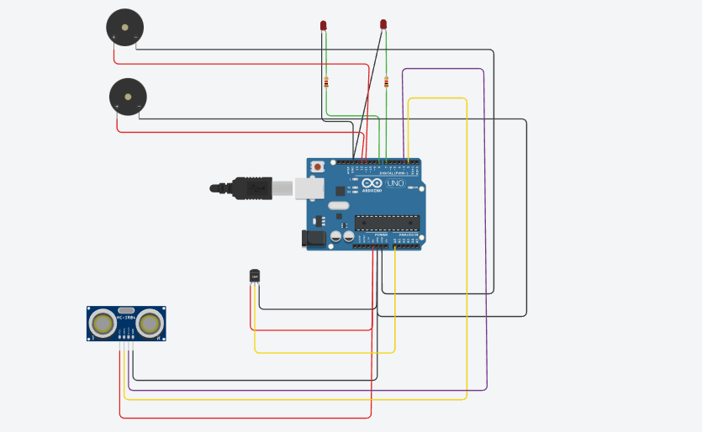

**SOURCE CODE**

## // C++ code

int t=2; int e=3;

void setup()

{

Serial.begin(9600); pinMode(t,OUTPUT); pinMode(e,INPUT); pinMode(12,OUTPUT);

}

void loop()

{

**//ultrasonic sensor** digitalWrite(t,LOW); digitalWrite(t,HIGH); delayMicroseconds(10); digitalWrite(t,LOW);

float dur=pulseIn(e,HIGH); float dis=(dur*0.0343)/2; Serial.print("Distance is: "); Serial.println(dis);

## //LED ON

if(dis>=100)

{

digitalWrite(8,HIGH);

digitalWrite(7,HIGH);

}

## //Buzzer for ultrasonic Sensor

if(dis>=100)

{

for(int i=0; i<=30000; i=i+10)

{

tone(12,i); delay(1000); noTone(12); delay(1000);

}

}

## //Temperate Sensor

double a= analogRead(A0); double t=(((a/1024)*5)-0.5)*100; Serial.print("Temp Value: "); Serial.println(t);

delay(1000);

## //LED ON

if(t>=100)

{

digitalWrite(8,HIGH); digitalWrite(7,HIGH);

}

## //Buzzer for Temperature Sensor

if(t>=100)

{

for(int i=0; i<=30000; i=i+10)

{

tone(12,i); delay(1000); noTone(12); delay(1000);

}

}

## //LED OFF

if(t<100)

{

digitalWrite(8,LOW); digitalWrite(7,LOW);

}

}

# TINKERCAD LINK

# https://www.tinkercad.com/things/ck5CMokNSPn-stunning-bombul/editel?tenant=circuits

# OUTPUT

